1.Compound X is a colourless liquid at room temperature.

a) A sample of pure X was slowly heated from –5.0 °C, which is below its melting point, to 90 °C, which is above its boiling point. Its temperature is measured every minute and the results are represented on the graph.

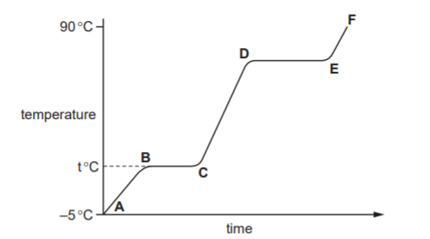

(i) Complete the equation for the equilibrium present in the region BC.

[1]

(ii) What is the signifi cance of temperature t°C? ................................................................................................................................[1]

(iii) What is the physical state of compound X in the region EF? ............................................................................................................................... [1]

(iv) What would be the difference in the region BC if an impure sample of X had been used? .............................................................................................................................. [1]

(b) Compound X is a hydrocarbon. It contains 85.7% of carbon. The mass of one mole of X is 84g.

(i) What is the percentage of hydrogen in the compound ? ....................................................................................................................................... [1]

(ii) Calculate the empirical formula of X. Show your working.

empirical formula = ................................ [3]

(iii) What is the molecular formula of compound X? ....................................................................................................................................... [1]

[Total: 9]

2.(a) Different gases diffuse at different speeds.

(i) What is meant by the term diffusion? ............................................................................................................................................. ....................................................................................................................................... [1]

(ii) What property of a gas molecule affects the speed at which it diffuses? ....................................................................................................................................... [1]

(b) Helium is a gas used to fi ll balloons. It is present in the air in very small quantities. Diffusion can be used to separate it from the air.

Air at 1000°C is on one side of a porous barrier. The air which passes through the barrier has a larger amount of helium in it.

(i) Why does the air on the other side of the barrier contain more helium? ....................................................................................................................................... [1]

(ii) Why is it an advantage to have the air at a high temperature? ............................................................................................................................................. ....................................................................................................................................... [1]

(c) Most helium is obtained from natural gas found in the USA. Natural gas contains methane and 7% helium. One possible way to obtain the helium would be to burn the methane.

(i) Write an equation for the complete combustion of methane. ....................................................................................................................................... [1]

(ii) Suggest why this would not be a suitable method to obtain the helium. ............................................................................................................................................. ....................................................................................................................................... [1]

(iii) Suggest another method, other than diffusion, by which helium could be separated from the mixture of gases in natural gas. ....................................................................................................................................... [1]

[Total: 7]

3. Petroleum contains hydrocarbons which are separated by fractional distillation.

(a) (i) Complete the following defi nition of a hydrocarbon.

A hydrocarbon is a compound which ......................................................................... .............................................................................................................................. [2]

(ii) Explain what is meant by the term fractional distillation. .................................................................................................................................... .................................................................................................................................... .............................................................................................................................. [2]

(b) Some of the fractions obtained from petroleum are given below.

State a use for each fraction.

bitumen ....................................................................

lubricating fraction ...................................................

paraffin fraction ........................................................

gasoline fraction ...................................................... [4]

[Total: 8]

4. 4 A list of techniques used to separate mixtures is given below.

filtration diffusion fractional distillation simple distillation crystallisation chromatography

From this list, choose the most suitable technique to separate the following mixtures. A technique may be used once, more than once or not at all.

(a) butane from a mixture of propane and butane ........................................................... [1]

(b) oxygen from liquid air ................................................................................................. [1]

(c) water from aqueous magnesium sulfate ..................................................................... [1]

(d) potassium chloride from aqueous potassium chloride ................................................ [1]

(e) silver chloride from a mixture of silver chloride and water .......................................... [1]

(f) glucose from a mixture of glucose and maltose ......................................................... [1]

[Total: 6]

5.The table gives the composition of three particles.

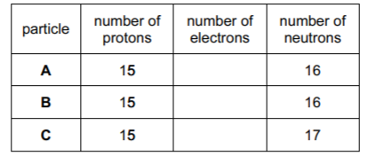

(a) What is the evidence in the table for each of the following?

(i) Particle A is an atom.

...............................................................................................................................................................................................................................................................................................................[1]

(ii) A, B and C are all particles of the same element.

...............................................................................................................................................................................................................................................................................................................[1]

(iii) Particles A and C are isotopes of the same element.

...............................................................................................................................................................................................................................................................................................................[2]

(b) (i) What is the electronic structure of particle A?

...............................................................................................................................................................................................................................................................................................................[1] (ii) Is element A, a metal or a non-metal? Give a reason for your choice.

.............................................................................................................................................................................................................................................................................................................. [1]

[Total: 6]

6.Protons, neutrons and electrons are subatomic particles.

(a) Complete the table to show the relative mass and relative charge of a proton, a neutron and an electron.

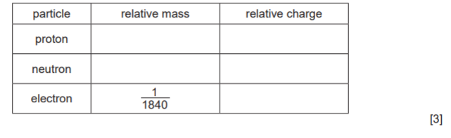

(b) Bromine has two isotopes.

(i) Define the term isotope. ............................................................................................................................................. ....................................................................................................................................... [2]

(ii) Explain why the two isotopes of bromine have the same chemical properties. ............................................................................................................................................. ....................................................................................................................................... [2]

(c) The table shows the number of protons, neutrons and electrons in some atoms and ions. Complete the table.

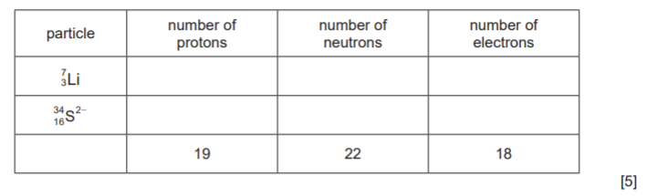

[Total: 12]

7.Carbonyl chloride is made from carbon monoxide and chlorine.



(a) Two methods of preparing carbon monoxide are from methane and oxygen, and from methane and steam.

(i) The reaction between methane and oxygen can also form carbon dioxide. How can carbon monoxide be made instead of carbon dioxide? ....................................................................................................................................... [1]

(ii) The following reaction is used to make carbon monoxide and hydrogen. The reaction is carried out at 1100 °C and normal pressure.



The reaction is reversible and comes to equilibrium. Suggest why a high temperature is used. ............................................................................................................................................. ............................................................................................................................................. ....................................................................................................................................... [2] (iii) What is the disadvantage of using a high pressure for the reaction given in (a)(ii)? ............................................................................................................................................. ....................................................................................................................................... [2]

(b) Chlorine is made by the electrolysis of concentrated aqueous sodium chloride. Describe this electrolysis. Write ionic equations for the reactions at the electrodes and name the sodium compound formed. .................................................................................................................................................... .................................................................................................................................................... .................................................................................................................................................... .................................................................................................................................................... .................................................................................................................................................... .............................................................................................................................................. [5]

(c) The structural formula of carbonyl chloride is given below.

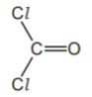

Draw a diagram showing the arrangement of the valency electrons around the atoms in one molecule of this covalent compound.

Use ○ to represent an electron from an oxygen atom.

Use × to represent an electron from a chlorine atom.

Use ● to represent an electron from a carbon atom.

[3]

[Total: 13]

8.Germanium is an element in Group IV. The electron distribution of a germanium atom is 2 + 8 + 18 + 4. It has oxidation states of +2 and +4.

(a) Germanium forms a series of saturated hydrides similar to the alkanes.

(i) Draw the structural formula of the hydride which contains three germanium atoms per molecule.

[1]

(ii) Predict the general formula of the germanium hydrides. .............................................................................................................................. [1]

(b) Draw a diagram showing the arrangement of the valency electrons in one molecule of the covalent compound germanium(IV) chloride, GeCl 4.

Use o to represent an electron from a chlorine atom.

Use x to represent an electron from a germanium atom.

[2]

(c) Describe the structure of the giant covalent compound germanium(IV) oxide, GeO2. It has a similar structure to that of silicon(IV) oxide. ........................................................................................................................................... ........................................................................................................................................... ..................................................................................................................................... [3]

(d) Is the change GeCl 2 to GeCl 4 reduction, oxidation or neither? Give a reason for your choice. ........................................................................................................................................... ..................................................................................................................................... [2]

[Total: 9]

9.(a) The diagram shows the lattice of a typical ionic compound.

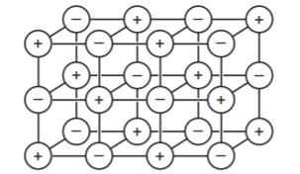

(i) Explain the term ionic lattice. .................................................................................................................................... .............................................................................................................................. [2]

(ii) In this lattice, the ratio of positive ions to negative ions is 1:1. In the lattice of a different ionic compound, the ratio of positive ions to negative ions is 1:2. Suggest why this ratio varies in different ionic compounds. .............................................................................................................................. [1]

(iii) Give three physical properties of ionic compounds. .................................................................................................................................... .................................................................................................................................... .............................................................................................................................. [3]

(b) Strontium oxide is an ionic compound. Draw a diagram which shows its formula, the charges on the ions and the arrangement of the valency electrons around the negative ion.

The electron distribution of a strontium atom is 2 + 8 + 18 + 8 + 2.

Use o to represent an electron from a strontium atom.

Use x to represent an electron from an oxygen atom.

[3]

[Total: 9]

10.

Substances can be classified as:

elements mixtures

Elements can be divided into:

metals non-

(a) Defi ne each of the following terms.

(i) element .................................................................................................................................... .............................................................................................................................. [2]

(ii) compound .................................................................................................................................... .............................................................................................................................. [2]

(iii) mixture .................................................................................................................................... .............................................................................................................................. [1]

(b) Classify each of the following as either an element, compound or mixture.

(i) brass .................................................................................................................... [1]

(ii) carbon dioxide ..................................................................................................... [1]

(iii) copper .................................................................................................................. [1]

(c) Which physical property is used to distinguish between metals and non-metals? It is possessed by all metals but by only one non-metal. ..................................................................................................................................... [1]

[Total: 9]

ANSWER KEY

1.

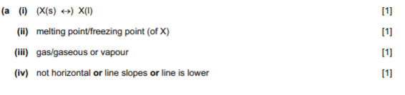

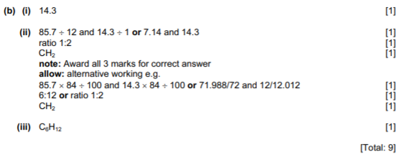

2.

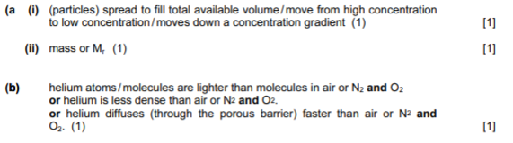

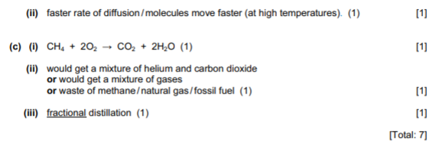

3.

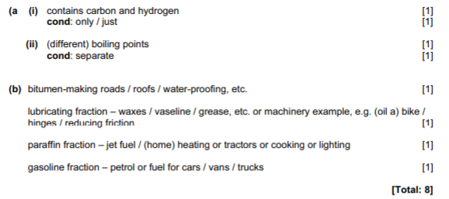

4.

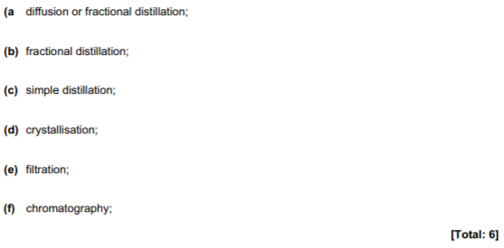

5.

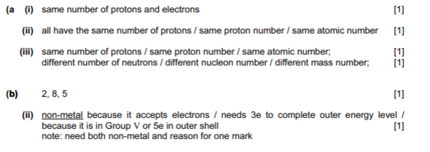

6.

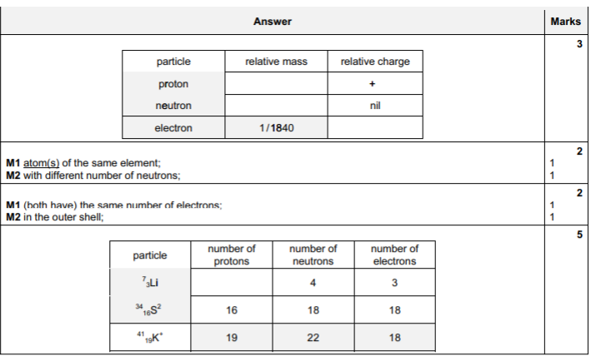

7.

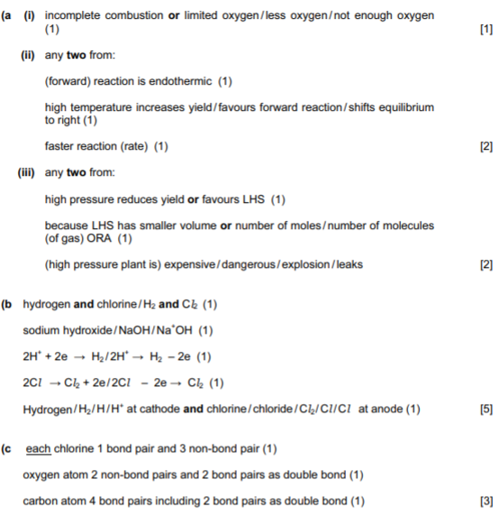

8.

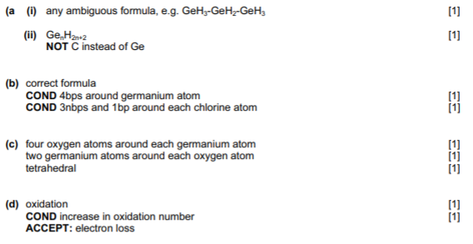

9.

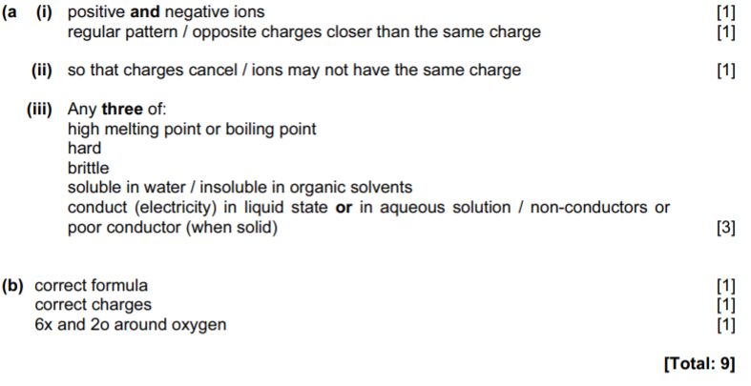

10.

